Activity: Understanding confidence intervals
Pre-reading

At this point in the course you have learned that a sample mean provides a single estimate of a population mean. Instead of reporting just a sample mean, you can report a confidence interval - an interval estimate that specifies a range within which the population mean is estimated to lie. In class, we will do an activity where we each sample data and calculate a confidence interval for the population mean based on the sample.

1. Preface
In the activity, the population of interest is a class of statistics students in Vancouver in 2016 [INSTRUCTOR: change this if not using the supplied data] and the parameter of interest is the mean height [INSTRUCTOR: change this if not using the supplied data]. In this case, it is feasible to collect data from the entire population and calculate the parameter of interest. Therefore, taking repeated samples and calculating sample means may seem redundant. However, in practice, we don’t always have access to population data. We can only obtain data from a sample, sometimes only from a small sample. This activity serves as a tool for us to understand the general behavior of confidence intervals.

2. Create a dataset by sampling from the population
Go to https://www.calculatorsoup.com/calculators/statistics/random-number-generator.php and generate 10 different random integers for taking a sample from the population. Set the minimum as 1, the maximum as 215 [INSTRUCTOR: change this and side screenshot if you use another data set], and the number of integers as 10, then click “Calculate”.  Use these 10 random numbers to pick the corresponding 10 subjects in the dataset of class heights [INSTRUCTOR: change this if not using the supplied data] (on the last page of this pre-reading); this is your sample. | 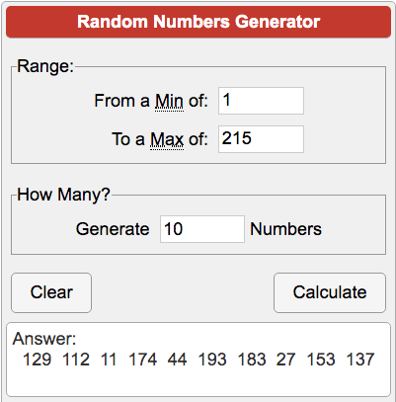
3. Calculate mean and standard deviation
Mean and standard deviation calculators are available online. You may go to this website:  https://www.easycalculation.com/statistics/standard-deviation.php  and use it to calculate the mean and standard deviation of your sample. The calculator outputs six numbers, but all you need are the two numbers as highlighted in the figure.  Practice a few times on how to use it. You may need to use it in class. Alternatively, you can calculate by hand with the formulas below. | 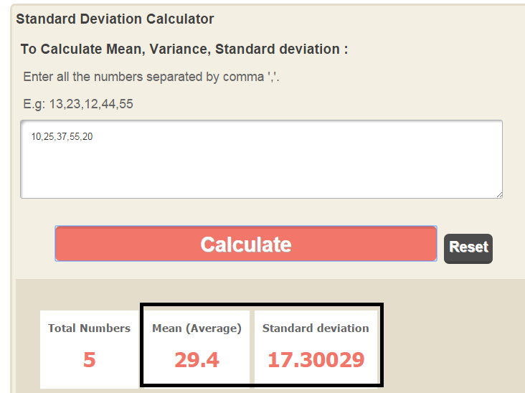

Notation: $x_{i}$ is the i-th observation, and $n$ is the number of observations.
Mean Formula: $\bar{x} =\frac{x_{1}+x_{2}+x_{3}+...+x_{n}}{n}$
Example: The average of $\{10,25,37,55,20\}$ is $\frac{10+25+37+55+20}{5}=29.4$.

Standard Deviation Formula: $s =\sqrt{\frac{{(x}_{1}-\bar{x })^{2}+(x_{2}-\bar{x })^{2}+{(x}_{3}-\bar{x })^{2}+...+{(x}_{n}-\bar{x })^{2}}{n-1} }$
Example: The standard deviation of$\{10,25,37,55,20\}$ is $\sqrt{\frac{(10-29.4)^{2}+(25-29.4)^{2}+(37-29.4)^{2}+(55-29.4)^{2}+(20-29.4)^{2}}{5-1} } =17.3$.

4. Calculate a confidence interval for the mean
The formula for the confidence interval for the population mean is:
$$\bar{x}±{t^{*}}_{n-1}×\frac{s}{\sqrt{n}}$$
where $\bar{x}$ is the sample mean, $s$ is the sample standard deviation, $n$ is the sample size, and ${t^{*}}_{n-1}$ is called the critical value. This ${t^{*}}_{n-1}$ is a value from what is called the t-distribution with n-1 degrees of freedom and can be found from tables or software. In our case, for n = 10 if we are calculating a 95% confidence interval then ${t^{*}}_{n-1}$is 2.26. Calculate a 95% confidence interval using your sample data.

Subj # | Height (cm) | Subj # | Height (cm) | Subj # | Height (cm) | Subj # | Height (cm) | Subj # | Height (cm) | Subj # | Height (cm) | Subj # | Height (cm)
1 | 180 | 32 | 177 | 63 | 176 | 94 | 173 | 125 | 174 | 156 | 176 | 187 | 163
2 | 160 | 33 | 178 | 64 | 183 | 95 | 162 | 126 | 163 | 157 | 181 | 188 | 170
3 | 170 | 34 | 178 | 65 | 165 | 96 | 160 | 127 | 160 | 158 | 158 | 189 | 185
4 | 158 | 35 | 160 | 66 | 170 | 97 | 173 | 128 | 160 | 159 | 184 | 190 | 180
5 | 169 | 36 | 156 | 67 | 157 | 98 | 155 | 129 | 185 | 160 | 163 | 191 | 148
6 | 190 | 37 | 170 | 68 | 165 | 99 | 163 | 130 | 183 | 161 | 169 | 192 | 170
7 | 170 | 38 | 155 | 69 | 161 | 100 | 167 | 131 | 166 | 162 | 177 | 193 | 170
8 | 184 | 39 | 160 | 70 | 170 | 101 | 152 | 132 | 161 | 163 | 160 | 194 | 160
9 | 148 | 40 | 156 | 71 | 179 | 102 | 180 | 133 | 165 | 164 | 169 | 195 | 173
10 | 176 | 41 | 163 | 72 | 178 | 103 | 152 | 134 | 166 | 165 | 165 | 196 | 175
11 | 175 | 42 | 192 | 73 | 195 | 104 | 163 | 135 | 166 | 166 | 165 | 197 | 180
12 | 152 | 43 | 175 | 74 | 160 | 105 | 172 | 136 | 174 | 167 | 177 | 198 | 161
13 | 160 | 44 | 170 | 75 | 165 | 106 | 183 | 137 | 163 | 168 | 172 | 199 | 183
14 | 179 | 45 | 165 | 76 | 177 | 107 | 177 | 138 | 164 | 169 | 167 | 200 | 163
15 | 170 | 46 | 186 | 77 | 164 | 108 | 156 | 139 | 171 | 170 | 167 | 201 | 162
16 | 165 | 47 | 162 | 78 | 165 | 109 | 165 | 140 | 175 | 171 | 162 | 202 | 178
17 | 175 | 48 | 158 | 79 | 165 | 110 | 185 | 141 | 180 | 172 | 168 | 203 | 160
18 | 178 | 49 | 173 | 80 | 177 | 111 | 183 | 142 | 157 | 173 | 166 | 204 | 160
19 | 168 | 50 | 170 | 81 | 172 | 112 | 180 | 143 | 170 | 174 | 165 | 205 | 150
20 | 155 | 51 | 183 | 82 | 100 | 113 | 180 | 144 | 158 | 175 | 173 | 206 | 160
21 | 162 | 52 | 178 | 83 | 164 | 114 | 179 | 145 | 168 | 176 | 170 | 207 | 175
22 | 155 | 53 | 164 | 84 | 180 | 115 | 167 | 146 | 152 | 177 | 160 | 208 | 174
23 | 167 | 54 | 174 | 85 | 181 | 116 | 177 | 147 | 165 | 178 | 194 | 209 | 174
24 | 186 | 55 | 183 | 86 | 158 | 117 | 170 | 148 | 165 | 179 | 170 | 210 | 164
25 | 203 | 56 | 159 | 87 | 154 | 118 | 180 | 149 | 153 | 180 | 165 | 211 | 164
26 | 168 | 57 | 160 | 88 | 173 | 119 | 170 | 150 | 170 | 181 | 186 | 212 | 188
27 | 160 | 58 | 174 | 89 | 172 | 120 | 164 | 151 | 183 | 182 | 185 | 213 | 171
28 | 180 | 59 | 172 | 90 | 165 | 121 | 170 | 152 | 170 | 183 | 161 | 214 | 165
29 | 157 | 60 | 192 | 91 | 160 | 122 | 179 | 153 | 170 | 184 | 161 | 215 | 172
30 | 173 | 61 | 168 | 92 | 154 | 123 | 178 | 154 | 170 | 185 | 157
31 | 152 | 62 | 183 | 93 | 152 | 124 | 177 | 155 | 162 | 186 | 150

